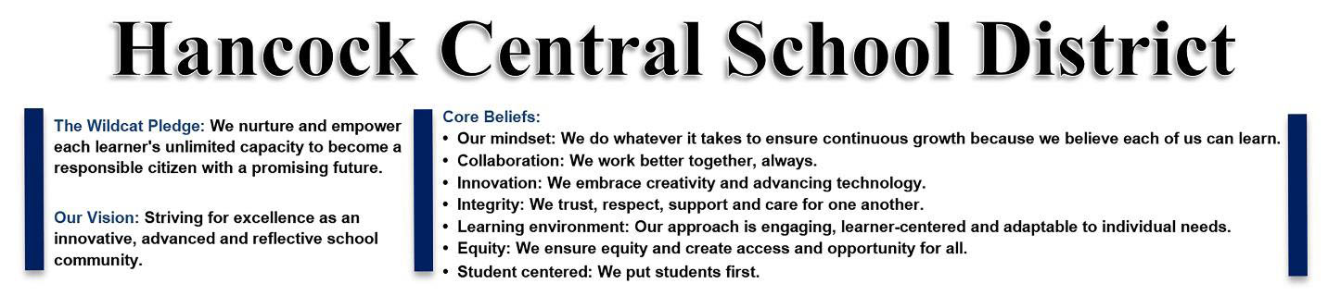
‘Cat Safety Committee discusses next steps for districtwide safety
HANCOCK – The Hancock Central School District (HCSD) held a ‘Cat Safety Study Planning Committee Meeting on Wednesday, April 26, 2023, discussed the distribution of the District Safety Plan, and reviewed the Community Letter Summary along with the most recent lockout situation.
During the meeting Hancock Central School District Superintendent Terry Dougherty released the current version of the 2022-2023 District-Wide School Safety Plan and highlighted lessons they learned from the March 28 lockout.
Dougherty said some of the lessons included the importance of prohibiting dismissal/release of students while a lockout drill or situation is in progress, increasing the frequency of emergency response drills, and keeping doors locked and closed.
He said that the HCSD Board of Education and Administrative Team will continue to swiftly and thoroughly investigate any incidents should they occur in the district. He added that on April 12 the HCSD held a public forum to encourage stakeholders to share their comments on how the district can improve moving forward.
The next meeting is scheduled to be held on May 2, 2023, and those who are interested in learning more about the district may visit its Facebook page at HancockCSD or the district’s website at hancock.stier.org for additional information.

